1 |  | A - purple
1 |  | B - brown
1 |  | C - yellow
1 |  | D - white
2 |  | A - purple
2 |  | B - black
2 |  | C - yellow
2 |  | D - white
3 |  | A - grey
3 |  | B - brown
3 |  | C - yellow
3 |  | D - black
4 |  | A - orange
4 |  | B - black
4 |  | C - yellow
4 |  | D - white
5 |  | A - pink
5 |  | B - black
5 |  | C - yellow
5 |  | D - orange
6 | 17 | A - seventy
6 | 17 | B - seventeen
6 | 17 | C - twenty
6 | 17 | D - eleven
7 | 24 | A – twenty-four
7 | 24 | B – twenty-five
7 | 24 | C – twenty-two
7 | 24 | D – twenty-one
8 | 60 | A - sixteen
8 | 60 | B - seventeen
8 | 60 | C - sixty
8 | 60 | D - seventy
9 | 42 | A - fourteen
9 | 42 | B – forty-two
9 | 42 | C – twenty-four
9 | 42 | D – forty-four
10 | 98 | A - ninety
10 | 98 | B – eighty-nine
10 | 98 | C – ninety-nine
10 | 98 | D – ninety-eight
11 | 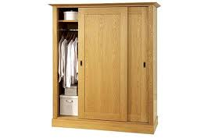 | A - wardrobe
11 |  | B - bed
11 |  | C - lamp
11 |  | D - pillow
12 | 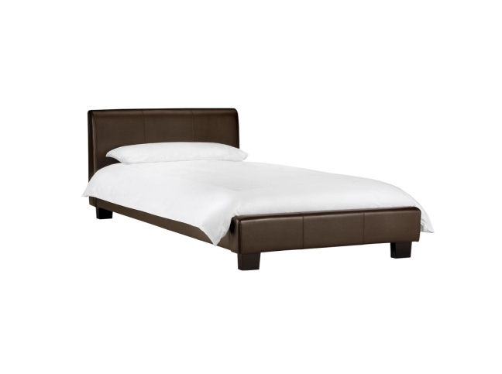 | A - wardrobe
12 |  | B - bed
12 |  | C - lamp
12 |  | D - pillow
13 | 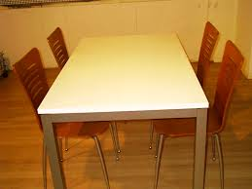 | A - table
13 |  | B - chair
13 |  | C - sink
13 |  | D - fridge
14 | 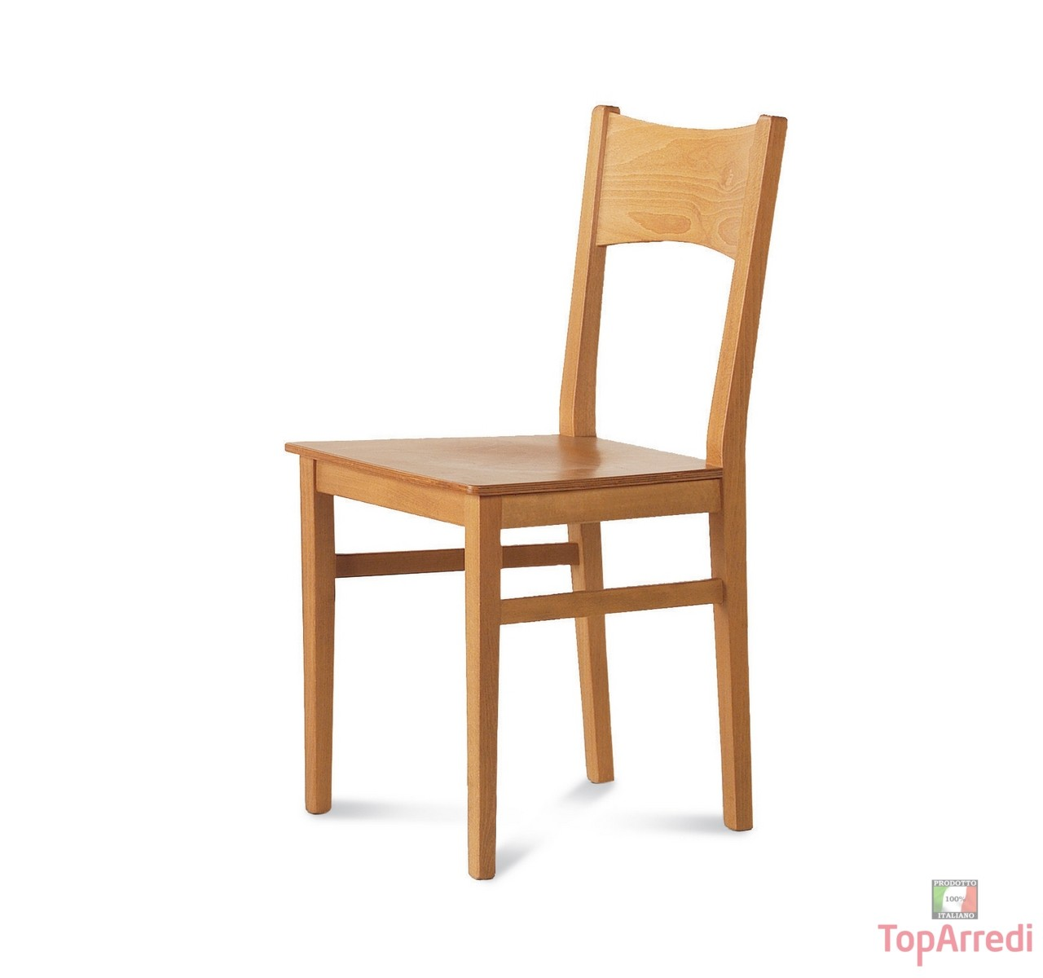 | A - table
14 |  | B - chair
14 |  | C - sink
14 |  | D - fridge
15 | 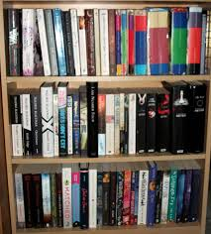 | A - sofa
15 |  | B - armchair
15 |  | C - television
15 |  | D - bookcase
16 |  | A - bathroom
16 |  | B - bedroom
16 |  | C – living room
16 |  | D - kitchen
17 | 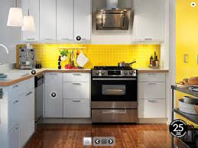 | A - bathroom
17 |  | B - bedroom
17 |  | C – living room
17 |  | D - kitchen
18 | 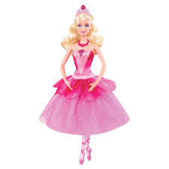 | A - computer
18 |  | B - scooter
18 |  | C - camera
18 |  | D - doll
19 | 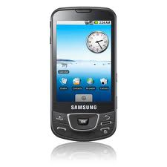 | A – mobile phone
19 |  | B - scooter
19 |  | C - camera
19 |  | D - doll
20 | 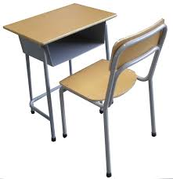 | A - schoolbag
20 |  | B - blackboard
20 |  | C – pencil case
20 |  | D - desk
21 |  | A - schoolbag
21 |  | B - blackboard
21 |  | C – pencil case
21 |  | D - rubber
22 | 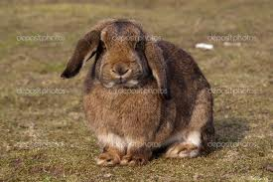 | A – brown dog
22 |  | B – black cat
22 |  | C – white horse
22 |  | D – brown rabbit
23 | 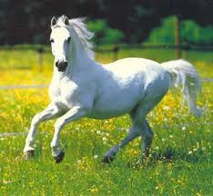 | A – brown dog
23 |  | B – black cat
23 |  | C – white horse
23 |  | D – brown rabbit
24 | 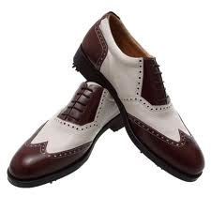 | A - trousers
24 |  | B - socks
24 |  | C - scarf
24 |  | D - shoes
25 | 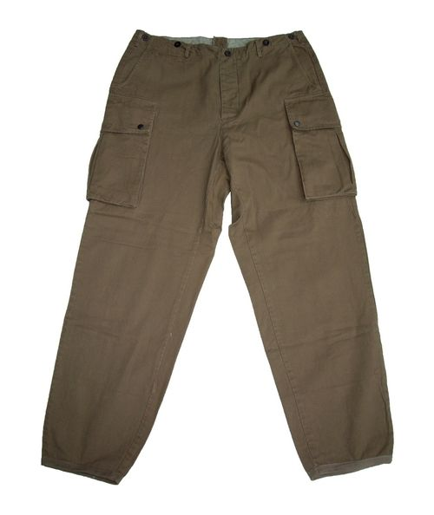 | A - trousers
25 |  | B - socks
25 |  | C - scarf
25 |  | D - shoes
26 | 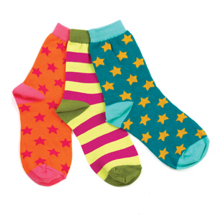 | A - swimsuit
26 |  | B - socks
26 |  | C - scarf
26 |  | D - hat
27 | 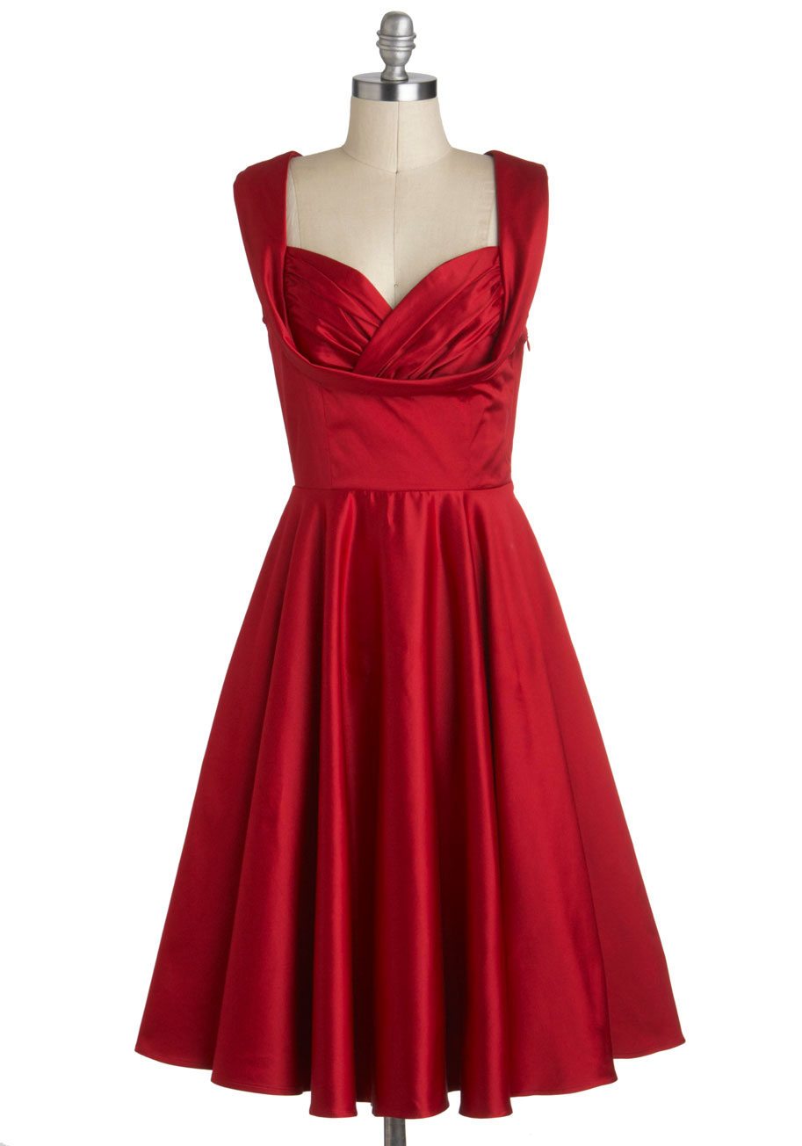 | A - dress
27 |  | B - socks
27 |  | C - scarf
27 |  | D - hat
28 | 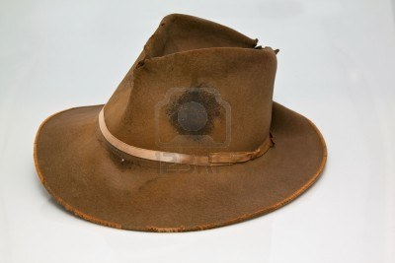 | A – The hat is old
28 |  | B – The hat is new
28 |  | C – The hat is grey
28 |  | D – The hat is black
29 | 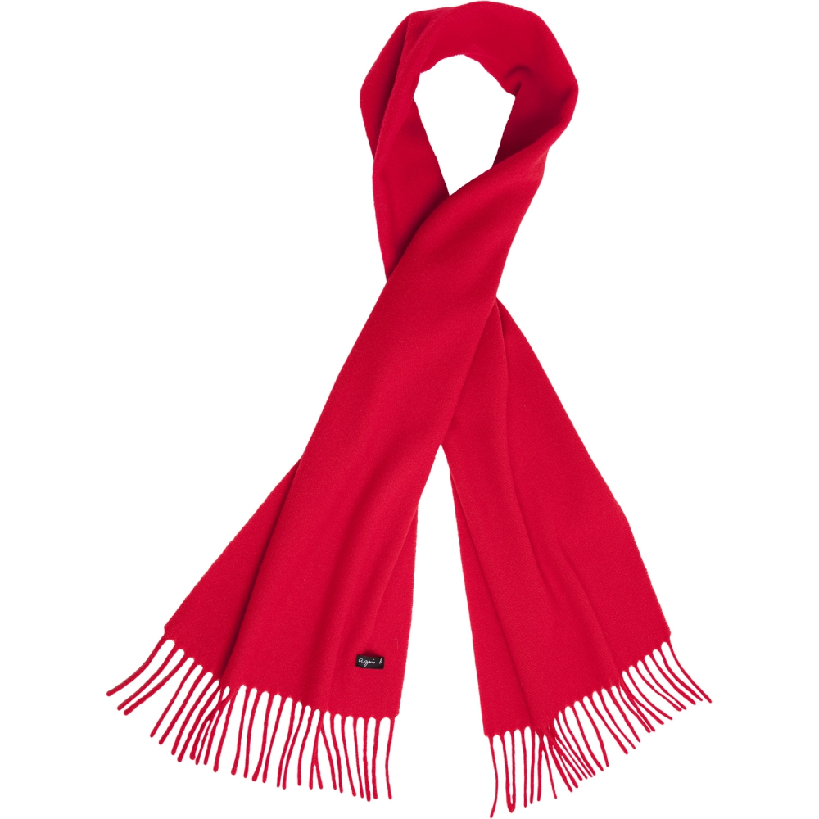 | A – The scarf is old
29 |  | B – The coat is new
29 |  | C – The scarf is red
29 |  | D – The scarf is orange
30 |  | A – This is a man
30 |  | B – This is a woman
30 |  | C – This is a boy
30 |  | D – This is a girl
31 |  | A – This is a man
31 |  | B – This is a woman
31 |  | C – This is a boy
31 |  | D – This is a girl
32 |  | A – spring
32 |  | B – summer
32 |  | C – autumn
32 |  | D - winter
33 |  | A – spring
33 |  | B – summer
33 |  | C – autumn
33 |  | D - winter
34 | 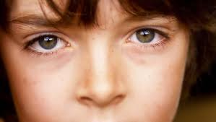 | A – head
34 |  | B – eyes
34 |  | C – hand
34 |  | D - leg
35 |  | A – head
35 |  | B – arms
35 |  | C – hand
35 |  | D -ear
36 | 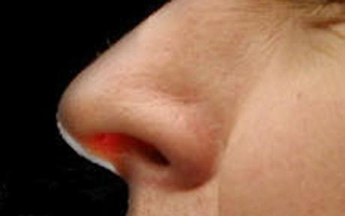 | A – nose
36 |  | B – eyes
36 |  | C – hair
36 |  | D - leg
37 |  | A – head
37 |  | B – eyes
37 |  | C – hand
37 |  | D - neck
38 | 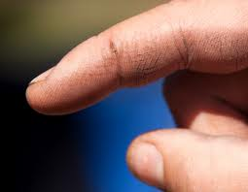 | A – mouth
38 |  | B – eyes
38 |  | C – finger
38 |  | D - leg
39 | 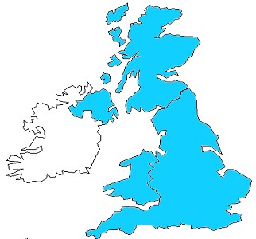 | A – Great Britain
39 |  | B – USA
39 |  | C – Italy
39 |  | D - France
40 | 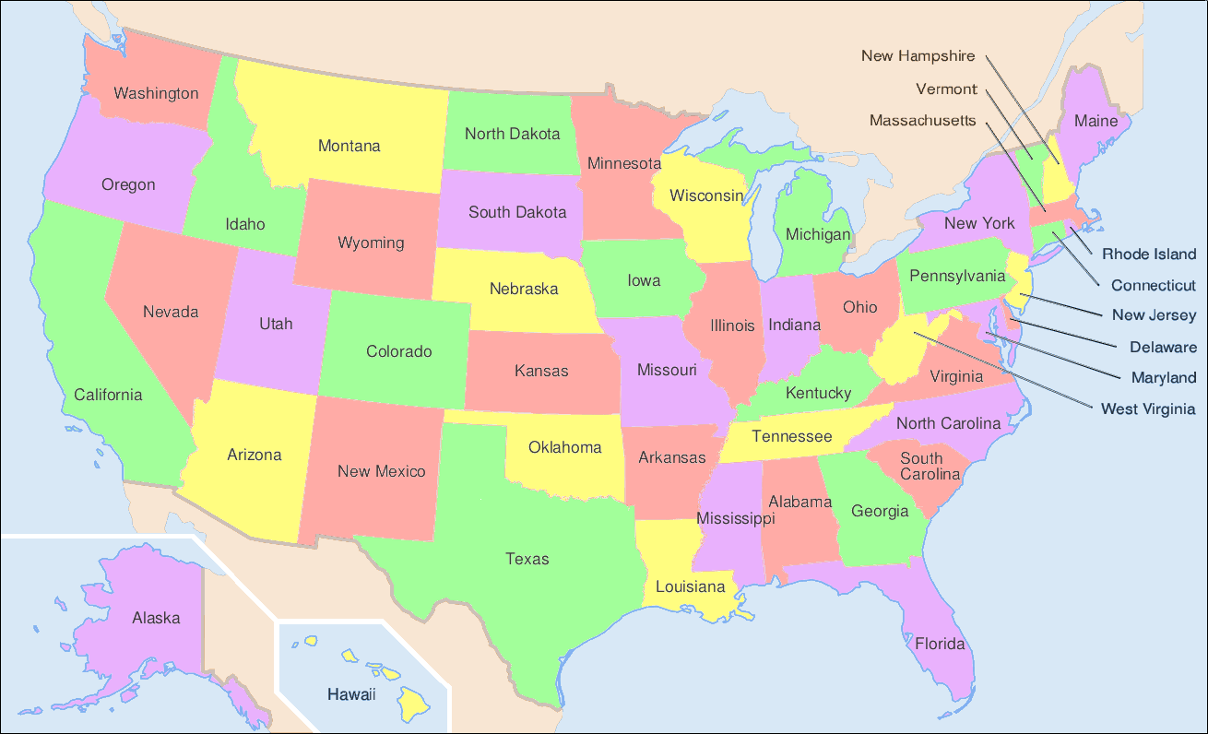 | A – Great Britain
40 |  | B – USA
40 |  | C – Italy
40 |  | D - France
41 |  | A - grandfather
41 |  | B – mother
41 |  | C – sister
41 |  | D - grandmother
42 |  | A - grandfather
42 |  | B – mother
42 |  | C – sister
42 |  | D - grandmother
43 | 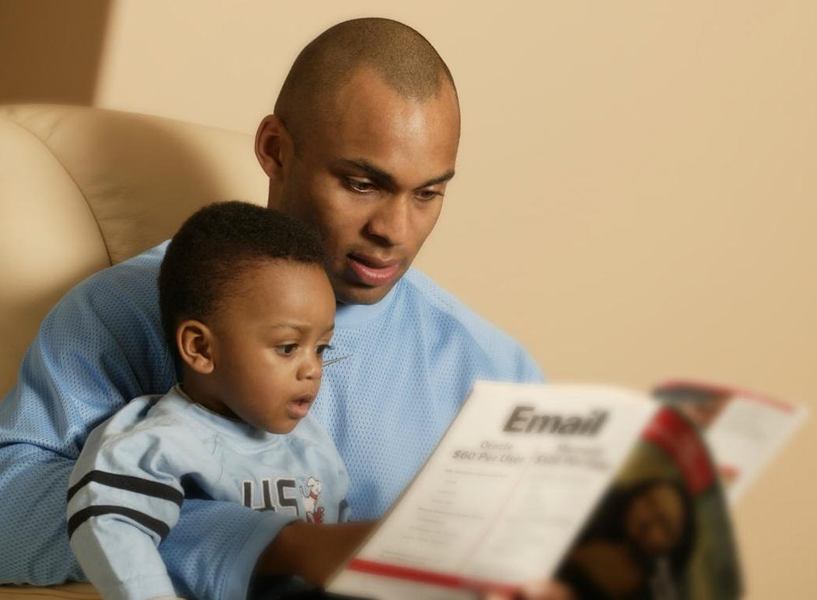 | A - brother
43 |  | B – mother
43 |  | C – father
43 |  | D - grandmother
44 | 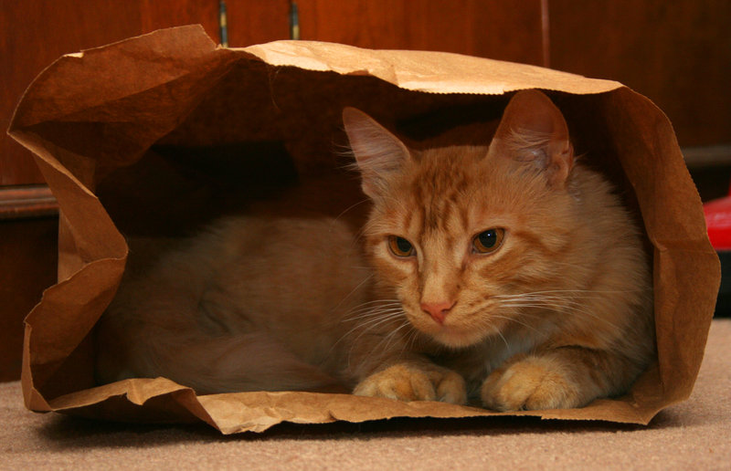 | A – The cat is on the bag.
44 |  | B - The cat is in the bag.
44 |  | C - The cat is under the bag.
44 |  | D - The cat is next to the bag.
45 | 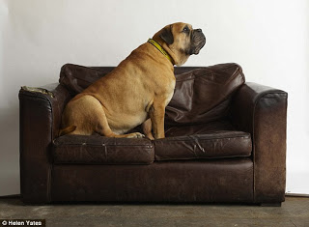 | A – The cat is on the sofa.
45 |  | B - The dog is under the sofa.
45 |  | C - The dog is on the sofa.
45 |  | D - The cat is next to the sofa.
46 | YOU ARE DOING AN ENGLISH TEST | A - True
46 | YOU ARE DOING AN ENGLISH TEST | B - False
47 | YOUR ENGLISH TEACHER’S NAME IS GIOVANNI | A - True
47 | YOUR ENGLISH TEACHER’S NAME IS GIOVANNI | B - False
48 | YOU LIVE IN ITALY | A - True
48 | YOU LIVE IN ITALY | B - False
49 | YOU CAN WRITE | A - True
49 | YOU CAN WRITE | B - Flase
50 | YOU CAN’T FLY | A - True
50 | YOU CAN’T FLY | B - False

